
一種使用去氧核醣核酸酶用於破壞感染性細菌生物膜及心內膜炎贅生物之用途

發明人：賈景山 教授
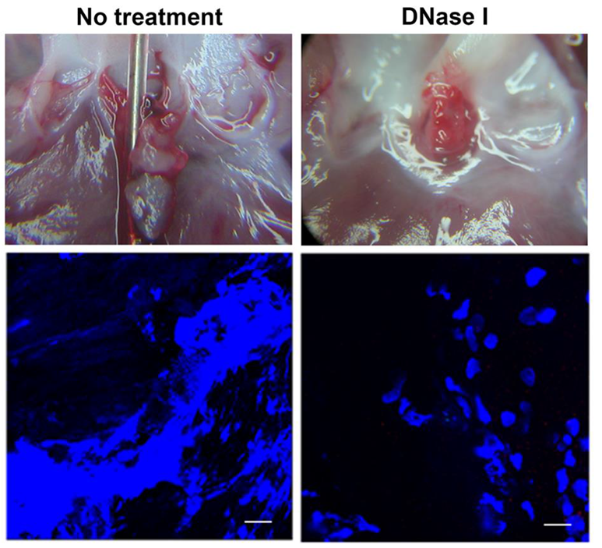
單 位： 國立臺灣大學免疫學研究所
簡 歷：
1. 1986~迄今, 主治醫師, 國立臺大醫院家庭牙科部
2. 2009~迄今, 教授, 國立臺灣大學免疫學研究所
3. 2002~迄今, 教授, 國立臺灣大學微生物學研究所
4. 1994~2002, 副教授, 國立臺灣大學微生物學研究所
5. 1991~1994, 兼職講師, 國立臺大醫院牙醫學院
6. 1982~1986, Residences; 助教, 國立臺大醫院牙醫學院牙科部
市場及需求: 致病菌會在人體內形成生物膜是導致對抗生素產生高抗藥性之主因。感染心內膜炎是一種典型的細菌生物膜相關的感染性疾病，通常由鏈球菌或金黃色葡萄球菌所引起，這些致病菌會因在生物體內的心臟瓣膜上形成生物膜而變成高抗藥性。心內膜炎的發生率約為每年每100,000人3.6人，但在一些先天瓣膜缺損的病人，發生率則更高，而其致死率高達30%，並倚賴長時期且高劑量的抗生素予以治療，此外，對於抗生素的預防性給予，其成果也是受備受爭議，所以，尋找治療及預防細菌生物膜引發之感染及心內膜炎的新方法是必要的。
技術摘要(含成果): 我們最近的實驗結果顯示，由嗜中性白血球釋放出的胞外網狀結構對於細菌在心臟瓣膜上形成生物膜扮演重要的角色，利用大鼠心內膜炎模式，我們證明了利用去氧核醣核酸酶將嗜中性白血球胞外網狀結構去除，可有效的減少在感染心內膜炎裡的細菌生物膜的形成，結果顯示去氧核醣核酸酶具有治療或預防感染性心內膜炎及其他細菌生物膜引發之感染症的潛力。
優勢: 我們的結果，嗜中性白血球釋放出的胞外網狀結構可幫助細菌在心臟瓣膜上形成生物膜，是領先國際的，有鑑於抗生素治療心內膜炎的效果有限，利用去氧核醣核酸酶治療心內膜炎的新方法，預期將可引起市場的興趣。
競爭產品:
- Pulmozyme : 已上市藥物但僅限cystic fibrosis 吸入性治療
專利現況:
- 我們已獲得的相關專利:
專利名稱: 評估及抑制細菌在心臟瓣膜形成生物膜的方法 (專利號I417383)
- 我們實驗室十年多以來長久的目標就是尋找可有效控制心內膜炎的方法，而我們的優勢在於我們利用已成功建立的大鼠心內膜炎模式從事相關研究。
聯絡方式(請不用填): 臺大產學合作總中心
Tel: 02-3366-9951, E-mail:lutepan@ntu.edu.tw
Invention
PI： Prof. Jean-San Chia
Graduate Institute of Immunology, College of Medicine, National Taiwan University
Experience:
1. 1986~present, Attending Physician, Department of Family Dentistry, National Taiwan University
2. 2009~present, Professor, Graduate Institute of Immunology, College of Medicine, National Taiwan University
3. 2002~present, Professor, Department of Microbiology , National Taiwan University
4. 1994~2002, Associate Professor, Department of Microbiology, National Taiwan University
5. 1991~1994, Lecture(Part-time), School of Dentistry, National Taiwan University
6. 1982~1986, Residences; Teaching Assistant, Department of Dentistry; School of Dentistry, National Taiwan University
Market Needs: Bacterial biofilm formation is the primary cause of antibiotic resistance. Infective endocarditis (IE) is a typical biofilm-related infectious disease, primarily caused by Streptococci or Staphylococci. The causal microorganisms become antibiotic-resistant in vivo through forming biofilm at the infected valves. IE has the characteristic high incidence rate of 3.6 cases per 100,000 per year and can be even higher among patients with pre-existing valvular heart disease, high mortality rate up to 30%, prolonged treatment course, and high recurrent rate. Moreover, the protective effect of the widely implied prophylactic antibiotics is controversial. Therefore, to search for new therapeutic and preventive strategies for bacterial biofilm and IE is imperative.
Our Technology: Our recent data showed that neutrophil extracellular traps from neutrophils (NETs) play significant roles in bacterial biofilm formation on the heart valve. By using rat IE experimental model, we demonstrated that disruption of NETs by using DNase I significantly reduce vegetation formation and bacterial colonization on the damaged valve. These data suggested that DNase I exhibit prophylactic and therapeutic potential for controlling IE and other bacterial biofilm related infectious diseases.
Strength: Our data showing NETs contribute to bacterial biofilm formation on the heart valve is pioneering. Due to the limitation of antibiotics in controlling bacterial biofilms and IE, the new strategy by using DNase I is anticipated to have promising marketing interests.
Competing Products:
- Pulmozyme: currently available drug for inhalation therapy of cystic fibrosis
Intellectual Properties:
- The related patent we have gained:
Patent title: 評估及抑制細菌在心臟瓣膜形成生物膜的方法 (patent number I417383)
- The log-term goal of our lab for at least 10 years is to search for the efficient therapeutic strategies for IE, and we are leading in the investigation of IE due to the well-established rat model of experimental endocarditis.

Contact (do not need to fill out):
Center for Industry-Academia Cooperation, NTU
Tel: 02-3366-9951, E-mail: lutepan@ntu.edu.tw

